1. 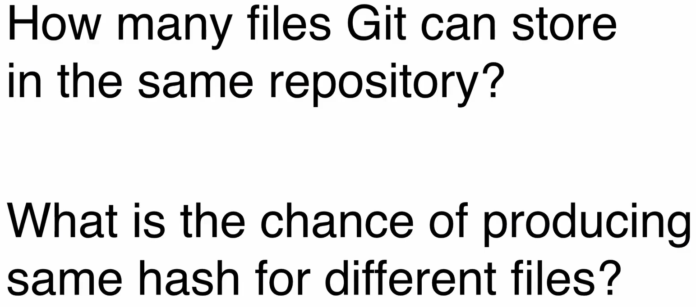
2. Second Question: hash Collision.
3. Let’s answer the first question.  
   
4. 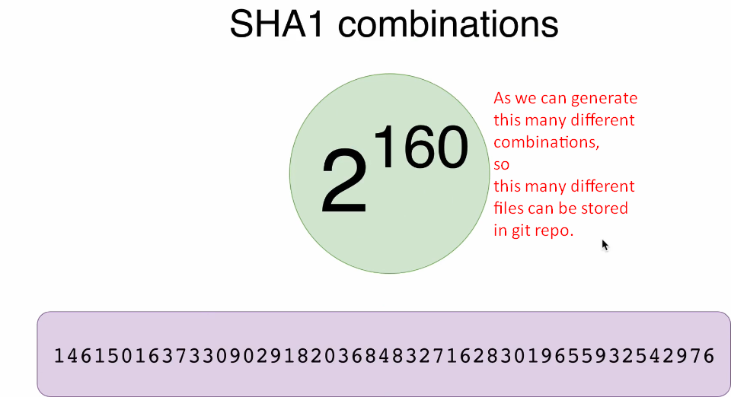
5. **Next Lec**:
6. 